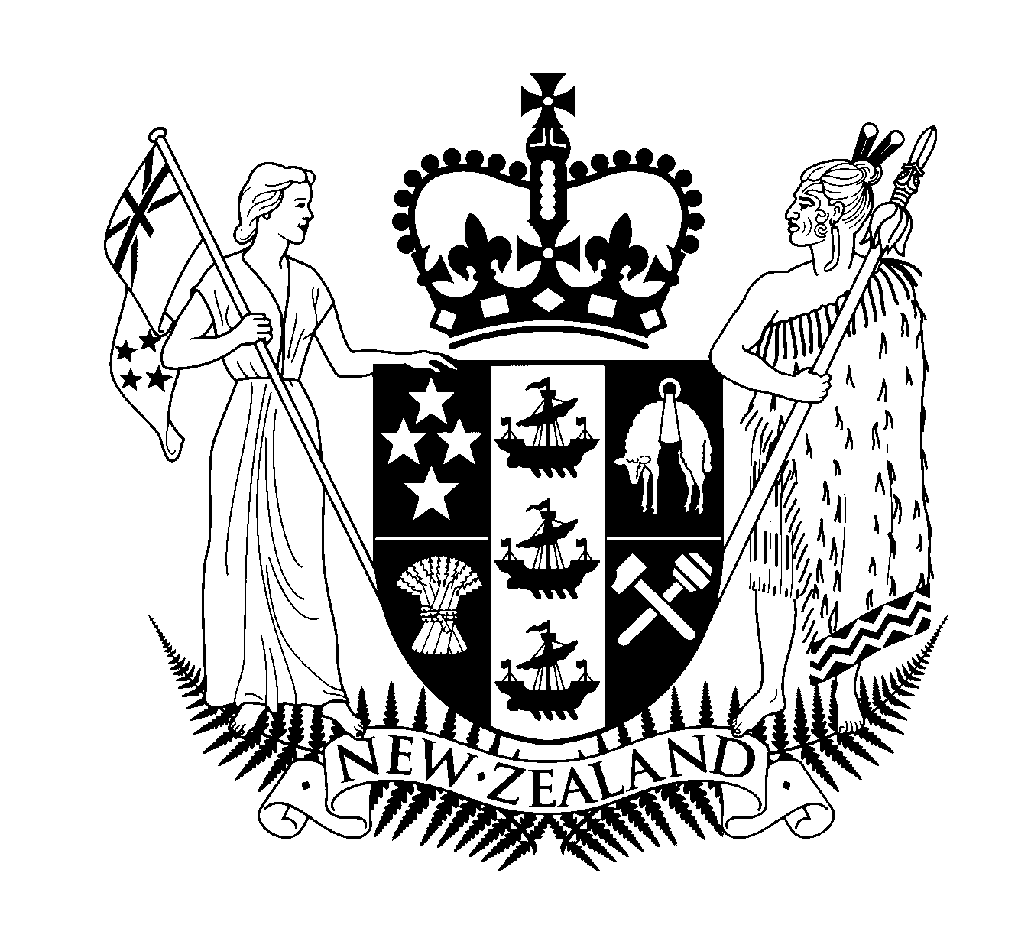Hon Judith Tizard

Minister of State
Associate Minister for Arts, Culture & Heritage
Associate Minister for Transport
Minister Assisting the Prime Minister with Auckland Issues
MP for Auckland Central
Media Statement

Parliament Buildings
Wellington
Phone: +64 4 470 6569
Fax: +64 4 495 8470

18 May 2000

PLEASE NOTE 12PM EMBARGO

Government announces major cash boost for arts, culture and heritage

The Government's significant injection of funding into to the arts, culture and heritage sector will revive creative industries in New Zealand and create jobs, said Auckland Central MP Judith Tizard.

"The Government is sticking to its pre-election promise to increase public investment in the sector. This cash boost will help enrich our country's cultural framework, create jobs and provide economic spinoffs," said the Associate Minister for Arts, Culture and Heritage.

Today's announcement by Prime Minister Helen Clark, sees an initial injection of more than $80 million into the sector and then ongoing funding increases of over $20 million a year in each of the next three years. The announcement also includes a series of one-off payments to organisations such as the New Zealand Symphony Orchestra and the Historic Places Trust.

A major new initiative sees the establishment of a Film Production Fund. There will also be a Music Industry Commission established to support the growth of popular music.

"Underlining today's announcement is my government's belief that our arts, culture and heritage are crucial to defining us as New Zealanders," said Ms Tizard.

"Our vision is for a strong and vibrant creative industry sector which provides sustainable employment and contributes to economic growth and prosperity.

"There will be significant economic spin-offs from the considerable investment the Government is making. For example, the government investment in the Film Fund will build on major film projects like Peter Jackson's Lord of the Rings, and create jobs and opportunities.

"Our investment in the arts, culture and heritage sector acknowledges the need to boost those organisations that have been financially starved in the past," said Ms Tizard.

The package includes:
- $20 million injection of funding into Creative New Zealand (the Arts Council of New Zealand).
- $22 million establishment grant to a new Film Production Fund.
- $2 million to establish a Music Industry Commission.
- An extra $7 million annual funding to NZ On Air, including $2 million for its music-related work, and $5 million for New Zealand TV programmes, especially children's TV. A cash injection of up to $27.909 million will be available to cover NZ On Air's shortfall this year after the last government's abrupt abolition of the Broadcasting Fee.
- A $3 million capital injection into the New Zealand Symphony Orchestra this year and an extra $1.4 million annually.
- An extra $2 million per annum operating funding for Te Papa and an extra $9 million per annum capital funding.
- A payment of $943,000 this year for the New Zealand Film Archive to extend its services.
- A cash injection of $760,000 this year into the Royal New Zealand Ballet to stabilise its finances.
- A $3 million cash injection this year for the New Zealand Historic Places Trust's new Preservation Fund, a Maori Heritage Development Fund, and enhancement of the Trust's national register. There is also a $170,000 budget increase this year, and an annual budget increase of $500,000 in following years.
- $6.474 million towards the development of the new Christchurch Art Gallery.
- $300,000 towards the restoration of the Picton-based historic ship, the Edwin Fox.
- The Ministry for Culture and Heritage's receives extra funding to enhance its ability to advise on cultural policy and to cover a range of transferred responsibilities.

Contact: Margot Staunton (press secretary) 04 471 9792 or 025 270 9124

